Standard | Items:
4.OA.03 -  Solve multistep word problems posed with whole numbers and having whole-number answers using the four operations, including problems in which remainders must be interpreted. Represent these problems using equations with a letter standing for the unknown quantity. Assess the reasonableness of answers using mental computation and estimation strategies including rounding. | 3.0  For each part of the problem write an equation using a variable to show your thinking.  Kelly bought two bags of marshmallows. One bag has 60 marshmallows. The other bag has 70 marshmallows. Kelly mixed the marshmallows and then separated them equally into 5 bowls.  Based on the information above answer a and b.  - How many marshmallows are in each bowl?  - If there was a 6th bowl, how many marshmallows would be left over if divided evenly?  For each part of the problem write an equation using a variable to show your thinking.  There are 12 doughnuts in a box. Scott brought in 3 boxes of doughnuts to class.  - How many doughnuts did Scott bring to class?  - The class ate 20 of the doughnuts. How many are left?  - There are 66 students in the fourth grade. About how many boxes would Scott need to bring to make sure every fourth grader gets at least one doughnut? Show your thinking.
2.0

Rick has $20. He bought a magazine for $4 and a bottle of water. He now has $15. How much did the bottle of water cost?

Carla reads 15 pages a day. (for use in T2)

- After 4 days, how many pages will she have read?
b. If the book is 120 pages, how many days will it take
her to read the entire book.

4.OA.04 -  Find all factor pairs for a whole number in the range 1–100. Recognize that a whole number is a multiple of each of its factors. Determine whether a given whole number in the range 1–100 is a multiple of a given one-digit number. Determine whether a given whole number in the range 1–100 is prime or composite. | 3.0  Part A: List all of the factor pairs of 24.  Part B: Is 4 a multiple of 24?  Part C: List the first four multiples of 6.  Part D: Is 24 a prime or composite number?
2.0

- List all of the factor pairs of 28.
- List the first four multiples of 8.

Solve this riddle.
Part A: I am a composite number between 50 and 60. Both of the factors that form me are prime numbers themselves. Which numbers might I be? Circle the possible numbers.

50, 51, 52, 53, 54, 55, 56, 57, 58, 59, 60

Part B: I am one of the numbers from Part A above. The sum of my factors equals a composite number. Which number am I? Explain.

Jadamian claims that half of the odd numbers that are
less than 100 are prime numbers. Is Jadamian correct?
Justify your answer.

4.NBT.01 -  Recognize that in a multi-digit whole number, a digit in one place represents ten times what it represents in the place to its right. For example, recognize that 700 ÷ 70 = 10 by applying concepts of place value and division. | 3.0  Baseball Game Attendance  Game Number of People  1 45,753  2 42,250  3 43,160  4 41,779  - Record the attendance for Game 2. Explain how the value of the 2 in the thousands place compares to the value of the 2 in the hundreds place.  - Write a division sentence that supports your answer.
2.0

In the number 660, the 6 in the hundreds place is _________ times as large as the digit to its right.

2.0

7,000 ÷ 10 = ________

4.NBT.04 -  Fluently add and subtract multi-digit whole numbers using the standard algorithm. | 3.0  Solve using the standard algorithm. Show your work.  Part A: 17,174 + 17,562 =  Part B: 18,118 - 7,174 =
2.0

Solve using any strategy. Show your work.

3,437
+ 1,942

2.0

Solve using any strategy. Show your work.

8,903 - 2,831 =

4.NBT.05  Multiply a whole number of up to four digits by a one-digit whole number, and multiply two two-digit numbers, using strategies based on place value and the properties of operations. Illustrate and explain the calculation by using equations, rectangular arrays, and/or area models. | 3.0  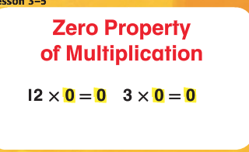 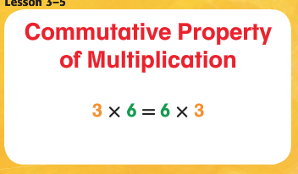  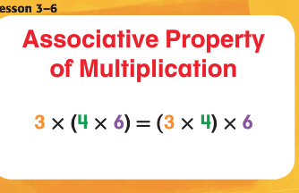 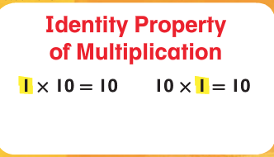  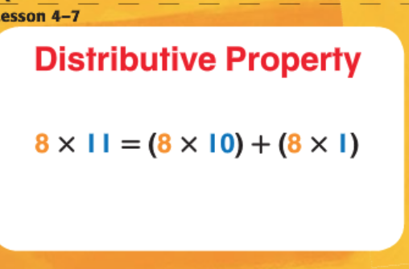 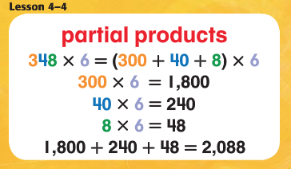  36 x 10 = 360  36 x 100 = 3600  36 x 1,000 = 36,000  - Using the strategy table above, solve 1,032 x 3 using one strategy  - Now, solve 25 x 55, using a different strategy than you already used.  - Solve 24 x 13 using equations, rectangular arrays, or area models. Show your work!  2.0  - Using any strategy, solve 3300 x 3.  - Using any strategy, solve 300 x 6.  - Using any strategy, solve 21 x 8.  - Using any strategy, solve 9 x 8.

